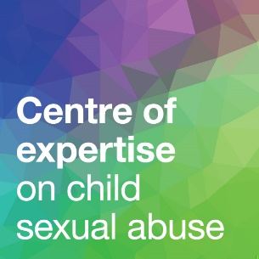
Child sexual abuse
support matrix
An audit template for
service funders and
commissioners
January 2025
This template is for use by the funders and commissioners of support services responding to child sexual abuse. It will help you to identify gaps in local support provision, so you can consider how to fill these gaps and meet the needs of everyone who requires support.
It is designed to be used in conjunction with our guide Funding and Commissioning Child Sexual Abuse Services: Why It’s Important, and How to Do It Well.
For each of the types of support listed, and each population requiring that support, you can use the template to record information about the support available in your area.

 | Immediate support | Practical and emotional support | Intensive crisis management support | Medical assessment and treatment | Specialist tailored support | Support with managing trauma symptoms | Support with addressing trauma | Peer support
Victims/survivors of child sexual abuse
Children
(aged 0–4)
Children
(aged 5–10)
Children
(aged 11–12)
Children
(aged 13–17)
Young adults
(aged 18–25)
Older adults
Non-abusing parents and other family members of sexually abused children
Family of children under 13
Family of children aged 13+
Children who have displayed harmful sexual behaviour
Children
Their parents
Their siblings
Adults who have sexually abused children, or who pose a sexual risk to children, and those adults’ families
Adults who pose a sexual risk to children
Families of people who have abused outside the family

