Developing the Response Pathway
Tender information
23 July 2025

Response Date: 14th August 2025

Milestone Dates:
- Clarification period – 23/07/25 – 05/08/25
- Responses to clarification issued – 11/08/25
- Tender evaluation – 15/08/25
- Supplier presentations – 18/08/25 or 28/08/25
- Notification of intent to award – 04/09/25
- Project kick off – 08/09/25

Key Contacts:
Peter East: Peter.east@csacentre.org.uk
Ian Dean: Ian.dean@csacentre.org.uk
Anna Glinski: anna.glinski@csacentre.org.uk
Appendix Contents:
- Brand overview
- Frequently asked questions
- Response Pathway usage data

Background

About the CSA Centre
The CSA Centre’s overall aim is to reduce the impact of child sexual abuse through improved prevention and better response, so that children can live free from the threat and harm of sexual abuse.
We are a multi-disciplinary team, funded primarily by the Home Office and hosted by Barnardo’s, working closely with key partners from academic institutions, local authorities, health, education, police and the voluntary sector. We aim to:
- increase the priority given to child sexual abuse, by improving understanding of its scale and nature
- improve identification of and response to all children and young people who have experienced sexual abuse
- enable more effective disruption and prevention of child sexual abuse, through better understanding of sexually abusive behaviour / perpetration.
We seek to bring about these changes by:
- producing and sharing information about the scale and nature and response to child sexual abuse
- addressing gaps in knowledge through sharing research and evidence
- providing training and support for professionals and researchers working in the field
- engaging with and influencing policy.
As a thought leader in child sexual abuse, we are grounded in both evidence and insights from those working in practice. We annually collate the latest evidence on the scale and nature of child sexual abuse in England and Wales, produce and commission research to fill knowledge gaps, create guidance and resources and deliver training to inform those working with children to better intervene, protect and respond to children and victims and survivors when there are concerns of child sexual abuse.
For more information on our work, please visit our website: www.csacentre.org.uk

About the Child Sexual Abuse Response Pathway
The Child Sexual Abuse Response Pathway is the CSA Centre’s interactive online resource to designed to help professionals understand the steps they can take to protect and support children, young people and their families when there are concerns of sexual abuse.
The Response Pathway is free to use and can be accessed from the CSA Centre website: https://www.csacentre.org.uk/child-sexual-abuse-response-pathway/
The Response Pathway has three key aims:
- Make the needs and perspectives of children central in professionals’ responses to child sexual abuse.
- Bring clarity to key points in a professional’s response to child sexual abuse, so they meet the needs of children who are being or have been sexually abused, and the needs of their families.
- Improve professionals’ responses to child sexual abuse by providing a pathway that is grounded in evidence and good practice.
The Response Pathway sets out how to respond to concerns of child sexual abuse at key points: from first concerns and early help safeguarding through to child protection and criminal justice. Throughout, the Response Pathway focuses on meeting the needs of children and their families.
It is designed to empower professionals to understand the role they, and their colleagues, can play to best protect and support children. It doesn’t just tell professionals what to do, it helps them to understand how to do it.
It builds on current legislation and statutory guidance and national policies and procedures to provide specific advice on child sexual abuse, it provides clarity on professional responsibilities, clearly outlining the steps to take and the actions required at key stages in the safeguarding and protection process. Importantly, this advice is centered around the needs of the child, how they are feeling and what they hope will happen. It also links to further information and resources to support professional practice.
Created for professionals working with children, each with their own safeguarding responsibilities, it’s particularly helpful for social workers, teachers, police officers, health professionals and those in the voluntary sector who work with children and families.

Project overview
For this project, the CSA Centre are seeking a team or organisation to build and host a redesigned, user-friendly version of our existing Response Pathway. Successful applicants should ensure they take a collaborative approach, working with staff at the CSA Centre throughout the process.

Objectives
- To improve the external design of the Response Pathway, so that more professionals are encouraged to use the resource, can easily find the guidance they are looking for, and are enabled to regularly use it in their own work.
- To improve the CMS behind the Response Pathway so the CSA Centre can easily edit and maintain its contents.
- To host the Response Pathway on infrastructure that is secure, reliable, scalable, and supports seamless integration with the CSA Centre’s main website.

Target Audience
The Response Pathway resource is designed for professionals working directly with children and families affected by child sexual abuse. This includes professionals with backgrounds in disciplines including but not limited to:
- Social work
- Education
- Healthcare
- Youth justice
- Policing
- Voluntary sector
They will not necessarily be child protection specialists, let alone specialists in child sexual abuse, and our target audience includes everyone from classroom assistants to consultant paediatricians.

Key Features
The Response Pathway is currently made up of a 2-page map of “decision points” linking to 34 pdf documents containing guidance for professionals at different stages of their response to child sexual abuse. These documents range from between 5 and 21 pages each (with an average length of 10 – 11 pages).
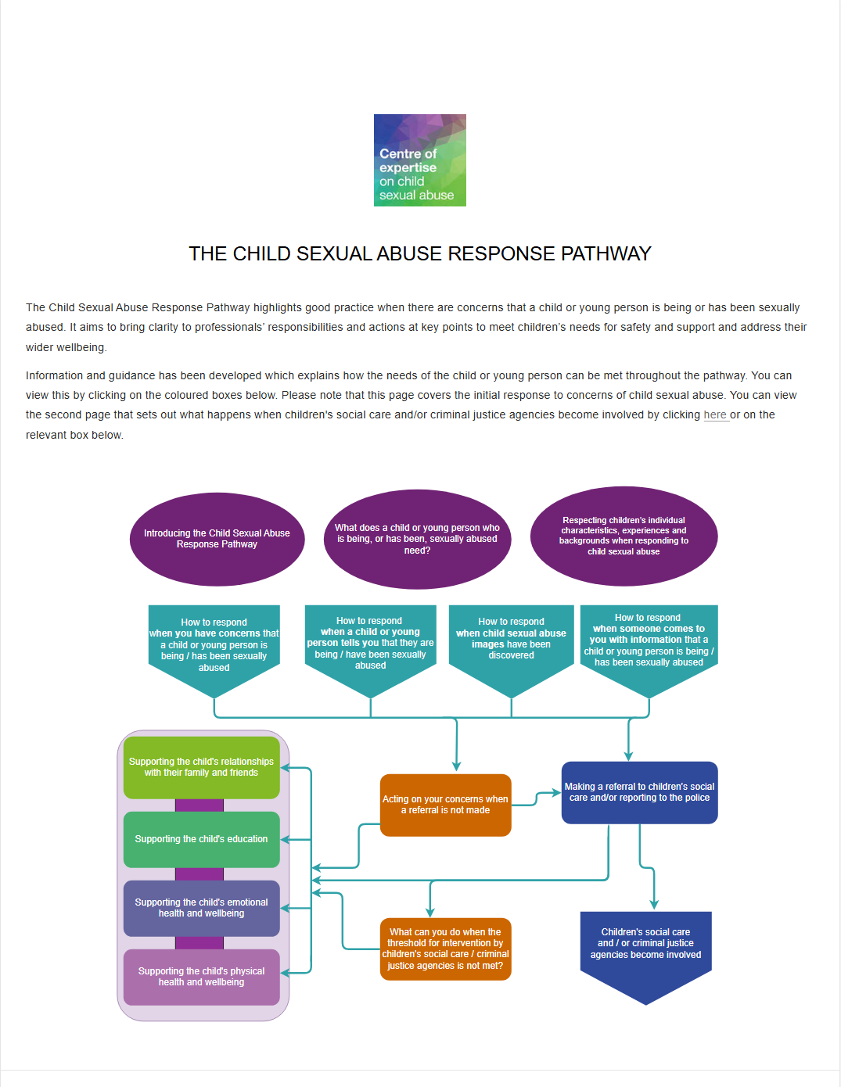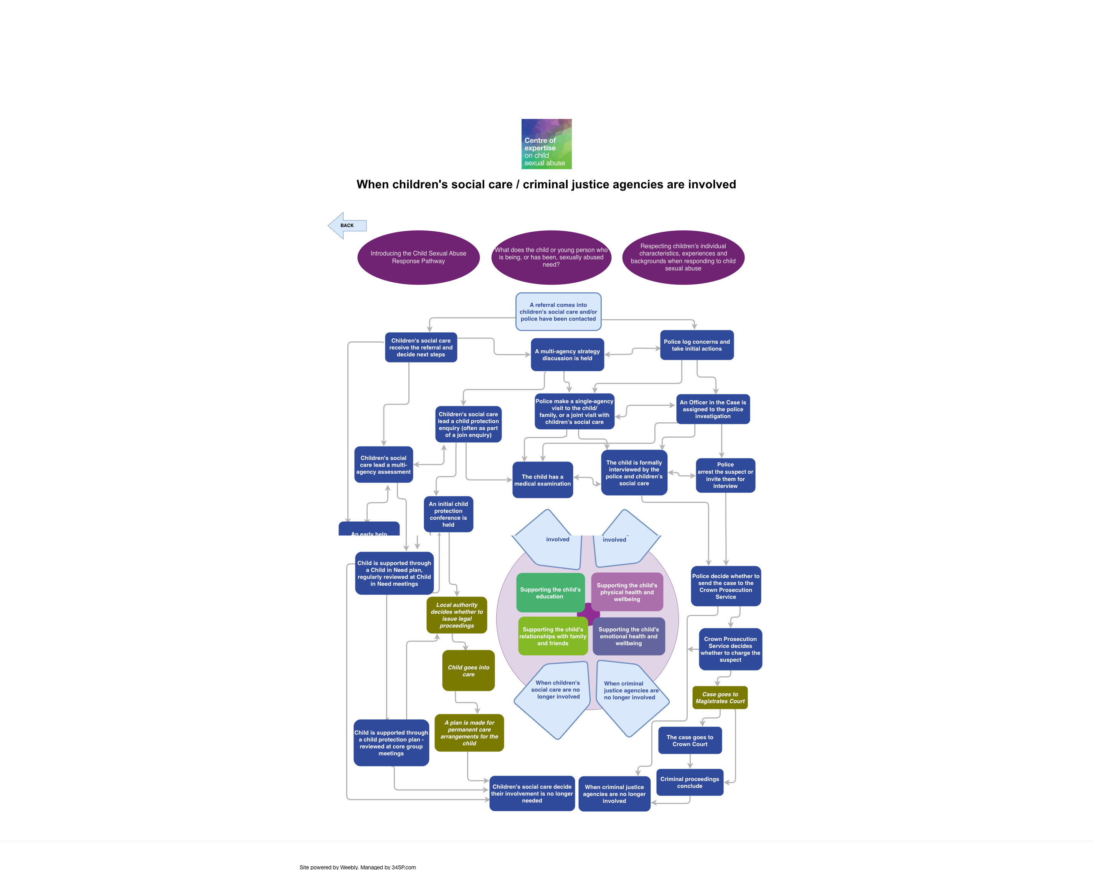
Current Response Pathway design
The re-designed version of the Response Pathway does not need to retain its current 2-page map structure or its current use of PDF documents. Instead, we are keen that the re-design of the Response Pathway ensures that:
- It is easy to navigate and use for all professionals of all disciplines: The new user interface of the Response Pathway must be easy for professionals to navigate, and must allow them to easily enter the Response Pathway at whatever stage of response they are seeking advice on. It must be accessible to different audiences, who each have different approaches to learning and engaging with professional guidance.
- The pathway must support multiple user types (e.g., police officers, social workers, teachers, GPs, etc.) and varied entry points (concerns, disclosures, image discovery, third-party reports), with overlapping and diverging steps.
- Users must be able to enter at any point, see previous/upcoming steps, and navigate freely - demanding a dynamic, stateful navigation system rather than a simple linear flow.
- The underlying content model must support branching, merging, and cross-linking of steps, and be maintainable as content evolves and expands.
- Information is presented in a concise and clear way: All information is currently contained within PDFs. The redesigned Response Pathway must present this information in a less overwhelming way for the reader, while maintaining important detail. This may mean moving away from using PDFs to present information, and allowing more detail to sit behind key points until selected by the reader. The types of content we might want to present include multimedia (images, video, audio) as well as text and documents.
- There are new visually engaging ways of displaying multi-media content: The updated Response Pathway should provide us with new ways to amplify and highlight children’s voices, practice insights and research evidence. This can include mirroring features from our existing resources such as pull quotes and ‘reflection points’, and new video and audio content.
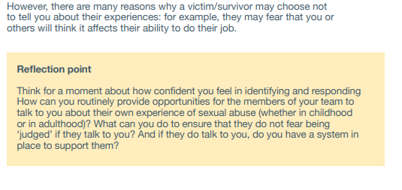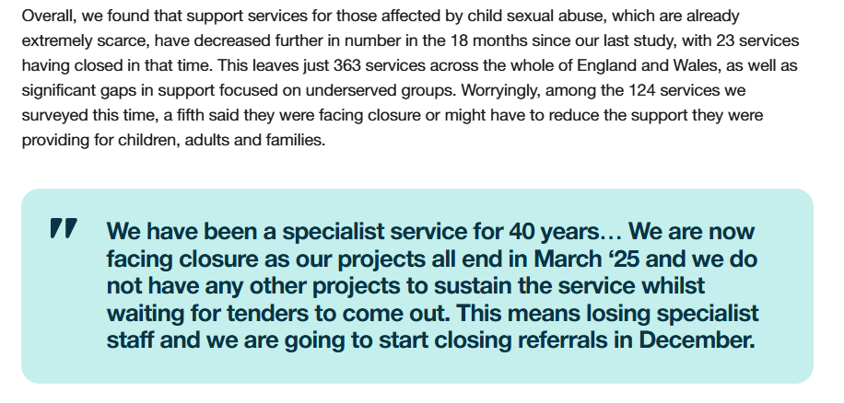
Examples taken from a CSA Centre practice resource, and a CSA Centre website blog post
- It matches the visual style and identity of the current CSA Centre website and resources: It is important that the Response Pathway is consistent with the existing style of CSA Centre resources, brand information will be provided to successful applicants.
- It can be accessed directly from the CSA Centre website: We want users to have a seamless experience between the Response Pathway and the CSA Centre website, even if not hosted on the same technical stack. This may require embedding or deep linking, and careful attention to branding, navigation, responsiveness and user session continuity.
- Specific key information can be made visible across the Response Pathway: We want the ability to highlight specific information from any point of the Response Pathway. Specifically, we want to ensure that professionals can always see the four ‘welfare strands’ at every point on the Response Pathway (this is discussed in more detail in the Key principles section below).
- Content can be easily managed and edited by the CSA Centre team: The team should be able to easily access the Response Pathway and edit content via a CMS with a user-friendly interface including tools such as a WYSIWYG editor and media library. Changes will be required often as and when legislation or statutory guidance is changed, requiring version control and possibly staged publishing. The underlying content model must support branching, merging, and cross-linking of steps, and be maintainable as content evolves and expands. The CMS must support complex, structured content (not just flat pages), including the ability to add, remove, or reorganize steps and maintain cross-references. A small number of roles and permissions may be needed to control content creation and publication.
- Content is searchable: to aid navigation around the Response Pathway, there needs to be functionality that allows users to search for specific content. They may be using different search terms depending on local practices. Users need to search by keyword or synonyms, with predictive results after entry of two or three letters to find steps or information quickly, requiring a robust, indexed search engine (e.g., Elasticsearch, Solr) integrated with the pathway’s content. Search must be fast, accurate, and accessible, supporting partial matches, synonyms, and also possibly include user-controlled filtering by user type or scenario.
- It can cross-connect to other CSA Centre resources: The Response Pathway frequently links to our existing practice resources, which must be possible from the redesigned version.
- It is fully responsive and device agnostic: our wide ranging professional audience will access the Response Pathway both from their offices and in transit. The application must be fully responsive, working seamlessly across desktops, tablets, and mobiles (min width 320px), with touch-friendly and accessible UI patterns. Interactive elements and navigation must be optimised for both mouse and touch, and layout must adapt to different screen sizes and orientations.
- It is compatible with major browsers: The solution must be fully compatible with the latest stable versions of all major browsers, including: Google Chrome, Mozilla Firefox, Microsoft Edge, Apple Safari. Support must extend to the two most recent major versions of each browser. The application should degrade gracefully on older versions, ensuring core functionality remains accessible even if advanced features are unavailable. The solution must be fully functional and responsive on mobile browsers: Safari for iOS (iPhone and iPad), Chrome for Android, Samsung Internet (latest version).
- It meets accessibility standards: The pathway must meet at least WCAG 2.2 AA accessibility standards, ensuring all interactive elements are perceivable, operable, understandable, and robust for users with disabilities. This includes keyboard navigation, screen reader compatibility, sufficient contrast, clear focus indicators, and tools to make multimedia accessible (captions, transcripts). Complex interactive elements (expandable steps, search, navigation) must be fully accessible.
- It supports multiple languages: The application must allow users to select their preferred language, with full support for both English and Welsh at launch and the ability to add additional languages in the future.
- It is SEO optimised: The pathway must be search engine optimised so that relevant steps and content are discoverable via Google and other search engines. Interactive, JavaScript-heavy content can be challenging for SEO; solutions may include server-side rendering or dynamic rendering to ensure search engines can index all relevant content. Proper use of structured data, metadata, and clean URLs is required.
- Its usage data can be analysed: Integration with an analytics platform is required to track usage patterns, entry/exit points, and user engagement.
- It is extendable and future proofed: The design must anticipate future expansion, such as new decision points (e.g., family law scenarios) and additional multimedia or resource links. The system must be modular and extensible, allowing new pathways, steps, or user types to be added without major redevelopment. We may want to offer other organisations the option of overriding the CSA Centre’s branding with their own branding or contact information in the future so this should be a consideration when designing the UI.
- It is performant and scalable: Interactive features (expand/collapse, navigation, multimedia) must not compromise app speed or stability, especially on lower-end devices or poor networks. The app must be optimised for quick loading, with code splitting, lazy loading of content, and efficient state management. Performance monitoring should be implemented to track usage and identify bottlenecks. We may need to consider the implementation of a CDN.
- It is reliable and available: Minimum uptime should be 99.9%. Standard backups should be stored on dedicated backup infrastructure – daily backup with 7 generations. Backup logs should be reviewed regularly to avoid corruption. There should be a business continuity plan for major incidents where they result in an outage and the recovery point objective and recovery time objective should be defined.
- It is secure: While the pathway may not collect personal data, robust security is still required to prevent unauthorised access to the CMS, tampering with content, or injection attacks.
- It complies with GDPR: It should include an opt in/out of cookies if it is the start of the user journey OR use the settings selected in the main website if it is a continuation of the journey. Cookies must be identified so they can be included in the cookies notice on the main website.
- It is maintained and supported: The application will be maintained with required patches, security updates and bugs. OS patching will be required if the application is hosted on its own infrastructure.
- It is owned by the CSA Centre: The CSA Centre will own the IP, code, assets and data, and reserve the right to modify or extend the application in the future. All IP should be assigned upon payment, no third-party claims or licenses should restrict the CSA Centre’s rights and the supplier will assist in transferring IP if needed.
As noted above, we are keen that there are opportunities throughout its development for collaboration between the CSA Centre and the chosen provider.

Why would users come to the Response Pathway?
There are many reasons why professionals would want to visit and use the Response Pathway, and these should be considered as part of the redesign. These include:
- To better understand what to do if they have a concern about sexual abuse, or if they are working on a case involving sexual abuse.
- To train new staff as part of an induction.
- As part of supervisions or team meetings.
- To understand the role and responsibilities of other agencies working to support children affected by child sexual abuse.
- For policy makers, in understanding the child protection processes around child sexual abuse when formulating new policies, legislation or guidance.
- For legal professionals, to understand the expectations on professionals working in sexual abuse cases.
- Although the resource is not aimed at children, parents or survivors of sexual abuse, it is likely that these groups may access the Response Pathway if seeking to better understand child protection processes and the action that different agencies should take.

Ultimately, when people use the Response Pathway we want them to:

Think:
- This is useful and easy to use
- I will visit this whenever I need to and advise others to do the same
- I can use this to support my practice and better protect and support children

Feel:
- Supported
- Confident
- Reassured
- Clarity
- Able to ask better informed questions

Do:
- Recognise and understand the child’s feelings and needs
- Apply the guidance in practice
- Proactively respond to their concerns about a child
- Respond directly to children’s needs, taking actions that will support children beyond the statutory steps
- Reflect on their own practice
- Encourage constructive challenge of colleagues’ practice or past decisions.

The development and use of the current Response Pathway
The CSA Centre created the Response Pathway between 2022 and 2024. It was initially piloted across three local safeguarding children partnerships (2023 – 2024) and links to it are currently embedded in local and regional safeguarding procedures, including London, West Midlands, Greater Manchester, Lincolnshire and Bristol. A further structured roll out supported by the CSA Centre is currently underway across the North West of England and West Midlands, as well as more ad hoc work to embed the Response Pathway in other local areas and regions.
In a recent report by the National Safeguarding Children Practice Review Panel (2024), local safeguarding children partnerships were recommended to consider taking a ‘pathway approach’ to how child sexual abuse is identified and responded to. The CSA Centre’s Response Pathway is one such pathway (and the only one of its kind that we are aware of) and it is hoped that LSCPs embed this in their areas.
The Welsh Government National Action Plan (2025 – 2035) also references such an approach. We are as a result expecting more partnerships to show an interest in utilizing this resource over the coming few years.
The CSA Centre has also been commissioned to develop further decision points for the Response Pathway, relating to private and public family law, this work is currently underway and will continue in parallel with the design activity. The design work will, however, need to take account of how this additional content will fit into the wider Response Pathway.
Feedback from users has largely been very positive, but suggests it can be overwhelming to use. This is particularly true of the current Pathway map, and to the scale of content in some decision points. There is some repetition of content throughout, though this is necessary as people will be accessing individual decision points directly.

Key principles of the Response Pathway
The principles that must be maintained in any redesigned version of the Response Pathway are:
- That it is helpful to everyone working with children, across all agencies and disciplines, whatever their role.
- Professionals are able to access evidence-based, best practice guidance as soon as they need it, starting at whichever decision point on the map for which they need advice. For example, if they are a teacher needing to make a referral, they can start there; if they are about to visit a home, as a police officer, they can start there; anyone going to a Strategy meeting can readily find that place.
- There is information (currently a document found at the top of the page) that introduces the Response Pathway, as well as information showing the principles on which the Response Pathway is based, and how it takes account of diversity.
- There are four ‘entry points’ which describe the usual ways in which child sexual abuse comes to light, and what should be done at this point. These are especially important, as the great majority of concerns about children who are sexually abused do not get further than these entry points.
- Information is written to address the person reading the material, encouraging them to take appropriate action themselves, rather than ‘referring on’.
- Fundamental to the Response Pathway are 4 ‘welfare strands’ relating to the child’s friends and family; emotional wellbeing; physical wellbeing; and education. Wherever a concern about a child sits within the Response Pathway, these points are highly relevant to them and must be considered, as such the 4 welfare strands can currently be found on both pages of the current map. This approach recognises that the Response Pathway would not usually be followed exactly; many children will go in and out of different processes, sometimes returning to earlier entry points.
- Real quotes from research with children appear early in each section, bringing diverse experiences to the reader, rather than only setting out what should happen as if that reflects reality (our experience, supported through research, is that best practice child protection processes rarely operate in practice, particularly in cases involving child sexual abuse).
- It works within existing law and guidance, and professionals need reassuring of this – it is not at variance with this in any way, but fills out aspects specific to child sexual abuse, since this is often little understood.
- Responding to diversity is important at every stage, and this is currently dealt with in a separate document that sits at the top of the page. The Response Pathway aims to cover all forms of child sexual abuse whilst balancing this with the need to be as concise as possible.
Month/year | Visits | Pages  visited
Jan 2023 | 551 | 1,337
Feb 2023 | 402 | 589
Mar 2023 | 507 | 974
Apr 2023 | 548 | 968
May 2023 | 731 | 1,553
Jun 2023 | 473 | 861
Jul 2023 | 372 | 606
Aug 2023 | 381 | 627
Sep 2023 | 498 | 832
Oct 2023 | 603 | 1,025
Nov 2023 | 508 | 879
Dec 2023 | 752 | 1,475
Jan 2024 | 606 | 1,239
Feb 2024 | 952 | 1,964
Mar 2024 | 850 | 1,571
Apr 2024 | 702 | 1,290
May 2024 | 829 | 1,535
Jun 2024 | 774 | 1,638
Jul 2024 | 712 | 1,245
Aug 2024 | 504 | 952
Sep 2024 | 742 | 1,319
Oct 2024 | 732 | 1,318
Nov 2024 | 925 | 1,676
Dec 2024 | 879 | 1,677
Jan 2025 | 889 | 1,621
Feb 2025 | 939 | 2,237
Mar 2025 | 1481 | 3,258
Apr 2025 | 1501 | 3,576
May 2025 | 1574 | 3,223

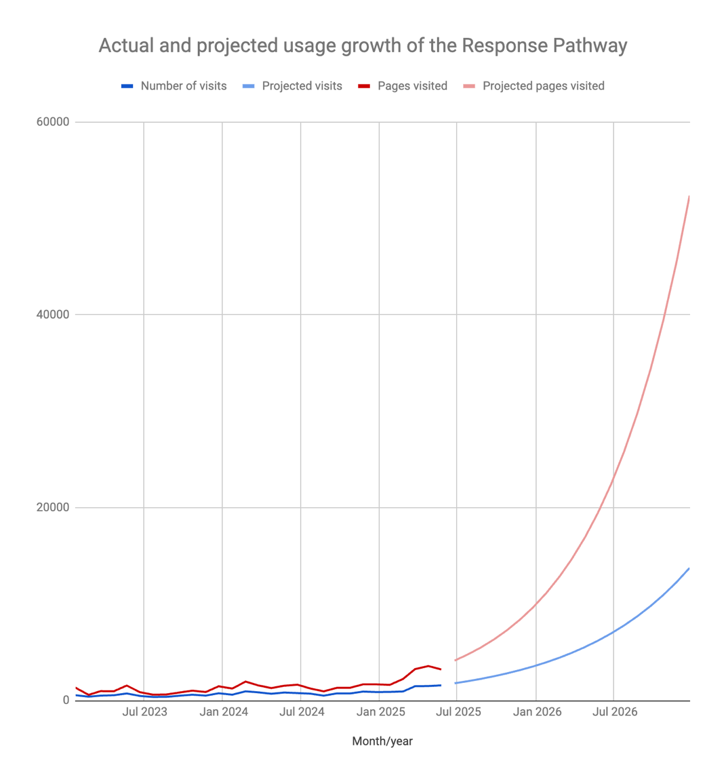
Usage information about the current Response Pathway

Also see data provided in Appendix D

Delivery methodology
We expect this project to be delivered using an agile, iterative methodology that supports close collaboration, transparency, and regular feedback. Suppliers should demonstrate experience with agile delivery and iterative prototyping, particularly in the context of user-centred design for complex digital services.

Key expectations

Agile Delivery
The project should be managed using agile practices, with work delivered in short, time-boxed iterations (sprints).

Iterative prototyping
During the design phase, suppliers must use iterative prototyping to enable the CSA Centre to review defined user journeys and conduct user testing of defined user journeys.
- Prototypes should be designed to allow for fast and inexpensive changes in response to feedback from both the CSA Centre staff and user groups.
- Prototypes should allow testing on defined device screen sizes for some of the defined journeys.
- The prototyping approach should prioritise flexibility, enabling rapid refinement of user journeys and interface elements before full design and development.

User testing
The CSA Centre will organise user testing sessions. Suppliers must support these sessions by providing prototypes suitable for testing, and incorporate findings into subsequent iterations.

Collaboration and communication
Regular, structured communication is essential. Suppliers should propose a plan for progress updates, sprint reviews, and planning sessions, and describe the tools and channels they use for collaboration (e.g., Slack, Teams, Trello, Jira, Monday).

Stakeholder involvement
Suppliers must work closely with CSA Centre stakeholders, including attending regular check-ins, presenting prototypes, demonstrating software and responding promptly to feedback.

Documentation
Suppliers should maintain clear documentation of user stories, design decisions, and changes throughout the project.

Software testing
Types of testing required and who is responsible
Type | Details | Responsible party
Unit testing | Automated tests at the code level to verify individual components | Supplier
Integration testing | Tests to ensure different modules or services work together as intended | Supplier
System and end-to-end testing | Validate the complete workflow and user journeys | Supplier
User Acceptance Testing (UAT) | Verifying that features meet acceptance criteria | The CSA Centre
Regression Testing | Ensure new changes do not break existing functionality | Supplier
Accessibility testing | Ensure site complies with WCAG 2.2 AA standard | Supplier  The CSA Center
Performance testing | Ensure the site performs against expected time benchmarks | Supplier
Security penetration testing | To test vulnerability and the ability for harmful penetration | Supplier

Storage
The CSA Centre’s storage requirements for documents and media will be confirmed during the discovery phase. Suppliers should propose a hosting solution that is scalable and can accommodate future growth in storage needs. Please consider how your solution will handle increasing storage volumes, the process for expanding capacity, and any associated costs or limitations.

Code repository
All source code and related assets must be managed in a secure, industry-standard version control system (e.g., Git). The CSA Centre will be granted full ownership of the repository from project initiation and will be given access if required. The supplier is responsible for maintaining a clear branching strategy, regular commits, and comprehensive documentation within the repository.

Release processes
The supplier must establish an automated release process, including versioning, tagging, and changelog management. Releases should be performed as agreed with the CSA Centre and with automated testing and deployment pipelines in place. Separate environments for development (which can be a cold standby after the initial launch) and production are required, with approval processes for production releases. Procedures for rollback and recovery must be documented and tested. All scripts and documentation must be transferred to the CSA Centre at project close.

Tender response
We expect the response to include:
- Proposed costs, including individual day rates and breakdown of wider costs
- Details of the team who will be working on the project
- Outline of approach to the design process, and to collaboration with the CSA Centre team
- Evidence of experience and examples of previous work
- Proposed timeline for delivery
- Specified deliverables
- Reference contact
Applicants are required to fill out the Supplier Response Form included in Appendix A, and applicants may also send in any additional materials to support their tender response.
- Proposals must address each criterion directly and provide clear, relevant evidence.
- The evaluation panel may seek clarification on any aspect of a submission.
- Shortlisted suppliers may be invited to present or clarify their proposals before final award.

Timetable
Step | Description | Indicative Duration
Tender Publication | Issue the tender notice and make all documents available to potential suppliers. | 24/07/25 – 14/08/25
Clarification Period Opens | Suppliers may submit questions regarding the tender requirements and process. | 24/07/25
Clarification Period Closes | Deadline for suppliers to submit clarification questions. | 05/08/25
Responses to Clarification Issued | All responses to supplier questions are published. | 11/08/25
Tender Submission Deadline | Final date and time for suppliers to submit their completed proposals. | 14/08/25
Tender Evaluation | Evaluation panel reviews and scores all compliant submissions against the published criteria. | 15/08/25
Supplier Presentations/Interviews | (If required) Shortlisted suppliers may be invited to present or clarify their proposals. | 18/08/25 or 28/08/25
Notification of Intent to Award | All suppliers are informed of the outcome. | 04/09/25
Contract Award and Signing | Contract is formally awarded and signed with the successful supplier. | 08/09/25
Project Kick-Off | Project initiation meeting with the chosen supplier. | 08/09/25

Tender scoring
Criteria area | Weighting (%) | Description
Quality and technical approach | 40% | Methodology, delivery plan, understanding of requirements, agile/iterative approach, risk management, and innovation
Experience and capability | 20% | Relevant project and sector experience, team expertise and case studies
Accessibility, security, and compliance | 10% | Approach to accessibility (WCAG 2.2 AA), security, GDPR, and other compliance requirements
Support, maintenance, and future-proofing | 10% | Ongoing support, maintenance, scalability, extensibility, and documentation
Cost and value for money | 20% | Itemised pricing, day rates, transparency, and demonstration of best value

Scoring methodology
Score | Description
0 | Unacceptable – no response or fails to meet the requirement
1 | Poor – partially meets the requirement; major gaps or weaknesses
2 | Acceptable – meets the requirement but with some minor gaps or limited detail
3 | Good – fully meets the requirement with clear evidence and relevant detail
4 | Excellent – exceeds the requirement, provides added value, and demonstrates clear strengths
Scores will be multiplied by the weighting for each criterion to produce a weighted score. The supplier with the highest total weighted score will be considered for contract award.

Price evaluation
Price will be evaluated against value for money, transparency, and alignment with the project’s requirements. Proposals that exceed the resources available to a not-for-profit may not be considered. The lowest compliant price will receive the highest score, with other prices scored proportionally.

Budget
The CSA Centre has a budget of £15,000 to £25,000, inclusive of VAT, to include all of the deliverables outlined in this brief. As a not-for-profit organisation we need to ensure that everything we deliver is as cost-effective as possible. Responses to this brief therefore need to fit within this remit, without over expenditure, though we will consider proposals for additional spend to further enhance the product, where applicable. In your response to this brief, please be specific about which deliverables are included in this budget and any which are additional.
This brief is for a the hosting, redesign and build of the CSA Centre’s Response Pathway and does not include the CSA Centre’s website or any other digital assets.

Assets and content
The CSA Centre is responsible for the content of the Response Pathway. We will provide this content as well as related images and brand guidelines to successful applicants.
The re-designed Response Pathway must align with the CSA Centre’s existing visual identity. We can provide template guidelines from our core publications, our practice resources and our website to help enable this.

Timeline
We are aiming to have a completed and publishable product by no later than March 2026. Timeliness of delivery will be factor in our decision making process.
Bids should provide a clear timeline of activity and deliverables.

Appendix A – Supplier response form
Supplier details
Supplier name
Company registration number or equivalent
Registered address
Website address
VAT registration number
Date of VAT registration
Bank name
Bank account number
Bank sort code
Suppliers must provide evidence of current insurance or a commitment to obtain the required cover before contract award:
- Professional indemnity: £2m
- Public liability: £2m
- Employers’ liability (if applicable): 20m
- Cyber liability (recommended but not mandatory): min £250k
Details of main contact
Name
Job title
Business address
Telephone number(s)
Email address

Executive summary
Keep to one side of A4. This should provide the CSA Centre with a clear, concise, and complete summary of your tender. Please outline your proposed technical approach, user-centred design methodology, and high-level ideas for structuring and managing the Response Pathway’s content and CMS. Highlight the key strengths of your proposal, provide insight into the reasoning and rationale behind your response, and demonstrate how your tender represents value for money to the CSA Centre.
We are not seeking detailed visual design concepts at this stage; instead, focus on how your approach will deliver an improved user experience, support effective content management, and align with the CSA Centre’s objectives.

A. Understanding of requirements and context
Keep your response to a maximum of one side of A4.
Please demonstrate:
- your understanding of the requirements of this project.
- your understanding of the CSA Centre and its aims.
- your understanding of the aims of the CSA Centre’s re-designed Response Pathway and this project can meet those aims.
B. Company experience
Keep your response to a maximum of two sides of A4.
Please demonstrate, by providing two case studies (including appropriate visuals), that:
- You have experience in creating interactive web-based digital products for a variety of audiences.
- Previous projects have aligned with clients’ brand identity.
- You have experience in working on similar briefs.
- You have experience of commissioning processes and working with a client, alongside how you envision the relationship working.
- You have experience of hosting, maintaining and supporting applications.
- Your experience is recent.
- You have relevant experience of working for not-for-profit or public sector clients (desirable not essential).

C. Capability and skills of the team
Keep your response to a maximum of one side of A4.
Please provide a detailed outline of the roles you propose for your project team, including the specific responsibilities and expertise each role will bring to the delivery of this project. Clearly identify the key personnel, their functions within the team, and how their skills and experience will contribute to the successful completion of the Response Pathway.
Please demonstrate that:
- There is a named scrum master.
- Your team has experience in UI, UX and interaction design.
- The roles and responsibilities of the project team are clearly defined.
- Contingency planning is in place with regard to the project team.
D. Outlined approach to meeting objectives
Keep your response to a maximum of one side of A4.
Please demonstrate:
- How the aims and objectives will be met.
- How you will manage the design and build of the Response Pathway, how the CSA Centre team will be engaged with during this process, and whether you are aware of any existing software or platforms that could be leveraged to meet our requirements and deliver cost or time savings.
- The rationale behind the chosen approach to the work.
- The SLAs related to supporting the application post go-live.
E. Timescales
Keep your response to a maximum of one side of A4.
Please set out clear timescales and indicate the actions required of the CSA Centre.
Please also provide:
- An outline of how you would structure the work, including sprint length, team composition, and typical deliverables per sprint.
- Any recommendations for managing scope, budget, and priorities in an agile context.
Please demonstrate that the timescales proposed are realistic and achievable.
Please provide examples of previous projects where timescales have been met.

F. Budget/expenses and value for money
Please provide a clear breakdown of proposed activities, the day rate of members of your team, and the number of days required to complete each task.
Day rates for each role you propose (e.g., developer, designer, scrum master)
Estimates for the number of days or sprints required for key phases (e.g., discovery, design (prototyping, final designs), MVP build)
Please demonstrate the added value your company would bring.
Estimated cost and effort (days) for the following phases:
- Discovery
- Iterative design and prototyping
- Infrastructure/repository and project tool set up and preparation
- One sprint of two-week duration
Day rate per role/blended day rate
Expenses incurred
Hosting, maintenance and support costs
Please include
- Hosting costs per month
- Storage costs per 100GB and 1TB (plus scaling costs)
- Estimated maintenance costs per month
- Day rate for support
- Cost for performance and penetration testing
Discounts/rebates you have applied
Other charges, e.g. cancellation fees
Please add further detail if necessary:

Declaration
I accept the CSA Centre’s terms and conditions | Yes / No  If No, please state which clauses you would wish to negotiate:
The documentation submitted constitutes my full and final tender response | Yes / No
My tender shall remain open for acceptance for a period of 90 days after the deadline for receipt of tender responses | Yes / No
Name of authorised person
Signature
Date

Appendix B: Brand Overview
What are the values and personality of the brand? What do they do? How do they want to be viewed?
The Centre of expertise on child sexual abuse (CSA Centre) aims to reduce the impact of child sexual abuse through improved prevention and better response.
Working closely with key partners from academic institutions, local authorities, health, education, police and the voluntary sector we believe that to tackle child sexual abuse we need to better understand its causes, scope, scale and impact.
Our multi-disciplinary team collates and analyses existing research, policy, practice and the experiences of survivors, and then seeks to fill the gaps with new research, insights and analysis. We then use that evidence and insight to develop new approaches and apply learning in practice through training and resources.
We believe that by professionals, researchers, policymakers, businesses and societies working together, we can tackle child sexual abuse.

Tone of Voice
The CSA Centre is a progressive organisation, sharing momentum for change in tackling child sexual abuse, rather than adding to the dark, creepy, damning images often depicted in media.
We Are: | We are not:
Supportive  Helpful  Friendly  Experienced  Latest / New / Up to date  Relatable  Conversational  Clean / Clear  Accessible  Inclusive  Robust | Fatalistic  Judgmental  Preachy  Dark  Greyscale  Shadows  Scary / Scared  Academic  Formal  Hierarchical / Elitist  Reductive  Stereotypes

Appendix C: Frequently asked questions
Taken from the CSA Centre Website, for professionals using the Response Pathway

Why did the CSA Centre create the Response Pathway?
One in ten children in England and Wales will experience some form of child sexual abuse before the age of 16, yet most of this abuse remains hidden. Surveys suggest that sexual abuse is as common as other forms of childhood abuse, such as emotional abuse or neglect, but it is much less likely to be identified by professionals. Those working with children need a clear understanding of the specific actions and processes they must follow when they have concerns of child sexual abuse, to be able to act to ensure the safety and well-being of every child.
The CSA Centre’s Response Pathway is an interactive online resource designed to empower professionals with the steps they can take to protect and support children and their families when there are concerns of sexual abuse. The resource sets out how to respond at key points: building on current legislation, statutory guidance, and policies, to focus on the needs of the child, how they are feeling and what they hope will happen. It is designed to help professionals understand the role they can play; not just by telling them what to do, but by helping them understand how to do it.

When should I use the CSA Centre’s Response Pathway?
The Response Pathway sets out how to respond to concerns of child sexual abuse at key points: from first concerns and early help safeguarding through to child protection and criminal justice. Throughout, the Response Pathway focuses on meeting the needs of children and their families. It is designed to empower professionals to understand the role they, and their colleagues, can play to best protect and support children. It doesn’t just tell professionals what to do, it helps them to understand how to do it.
Building on current legislation and statutory guidance and national policies and procedures to provide specific advice on child sexual abuse, it provides clarity on professional responsibilities, clearly outlining the steps to take and the actions required at key stages in the safeguarding and protection process. Importantly, this advice is centered around the needs of the child, how they are feeling and what they hope will happen. It also links to further information and resources to support professional practice.
Created for professionals working with children, each with their own safeguarding responsibilities, it’s particularly helpful for social workers, teachers, police officers, health professionals and those in the voluntary sector who work with children and families.
How can my Safeguarding Childrens Partnership or Board implement this?
The CSA Centre is hosting a series of one-hour webinars over the coming months, free of charge and available to all, to explain more about the Response Pathway and how it can be implemented locally. They have also created an implementation guide to support use and show how it can be embedded across services. See www.csacentre.org.uk for dates and booking details.

How does this differ from statutory guidance and legislation? Or national and local policies?
The Response Pathway builds on current legislation and statutory guidance and existing local and national policies and procedures to provide specific advice on child sexual abuse. The resource provides clarity on professional responsibilities, clearly outlining the steps to take and the actions required at key stages in the safeguarding and protection process. Importantly, this advice is centered around the needs of the child, how they are feeling and what they hope will happen.

How long does the Response Pathway take to read?
The Response Pathway is designed to be actively used, so it can be revisited throughout the process of working with a child, and their family, when there are concerns. Rather than being a resource that is read in its entirety, it offers specific guidance at different points in the response to concerns of sexual abuse: from identification of first concerns through to strategy meetings and criminal justice stages. It can be used to navigate processes, to understand the multi-agency process, to ground action in the needs of a child and to access wider resources to support professional response. The time taken to do this will depend on the needs of the professional and the children they are working with. We would encourage professionals to revisit the Response Pathway regularly, to help shape their response and support.

Appendix D: Response Pathway usage data

Total number of individual pdf downloads

