Child sexual abuse training: Self care

Sexual abuse can be difficult to think about and talk about. Thinking about it and talking about it will affect us all in different ways, at different times.

In light of this training being delivered online, most or all of you will be taking part from your own homes. This presents particular issues around:

* Privacy – the risk of exposing your family members to difficult material or feeling restricted as to how much you can contribute to discussions
* Boundaries – not being able to leave the content at work in the same way you would do if attending face to face training
* Time to debrief – not having the usual periods of time to either be alone or catch up with colleagues after a face-to-face session, for example, during the drive home
* Containment – not being ‘held’ by the facilitator in the same way as in face-to-face training

We know that a high number of people experience child sexual abuse and we can therefore assume that some of you attending this session today have either experienced sexual abuse yourself, or have a family member or friend who has been sexually abused – this may be your own child, a partner, a parent.

Here are some things you may wish to consider before the session (many of which you will already have in place already):

* Letting others in your home know that you will need privacy during the session.
* Using headphones so that family members are not exposed to difficult content.
* Allowing yourself some time after the presentation to debrief form the material.
* Letting supportive family members know if you feel you may be impacted by the material.
* Pre-arranging a post-session check in with a friend of family member.
* For those who have lived experience of sexual abuse, thinking about which of your current coping strategies you could employ after the session if you are affected by the content.

## During the Session

You may decide that today just isn’t the day to do the session, and you may not realize this until you are in it! So, it’s important to be kind to yourself:

* If you need a break from the material, then you can do this by leaving the session at any point
* If you find any parts of the session particularly hard, you can do the following grounding exercise at any point. We will also practice this within the training.

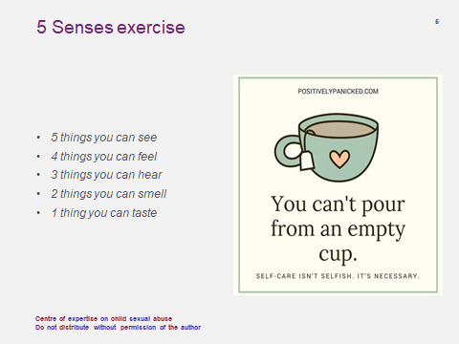

## After the session

If you are affected by anything that is discussed during the session:

**The Survivors Trust**

Find help, support and advice in your area:  [The Survivors Trust](https://www.thesurvivorstrust.org/)

**Rape Crisis helpline – 0808 500 2222**

Open 24 hours a day, every day of the year.

Call to speak to a trained specialist, who can also tell you where your nearest services are located if you would like face-to-face support or counselling.  [www.rapecrisis.org.uk](http://www.rapecrisis.org.uk/)

**National Association for People Abused in Childhood –** [**0808 801 0331**](tel:0808%20801%200331)

Open 10am – 9pm Monday to Thursday, 10am – 6pm on Friday.

NAPAC offer specialist support

For more information, please see their website: <https://napac.org.uk/>

**SurvivorsUK**

Monday to Sunday, 12pm – 8pm

Online help for male survivors of sexual abuse and rape. [SurvivorsUK | We challenge the silence to support sexually abused men](https://www.survivorsuk.org/)